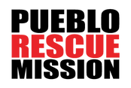
MENTORSHIP PROGRAM
The focus of the mentoring program is to help with rehabilitative and spiritual needs through one’s faith in Jesus Christ using a continuum of care creating a growing, healthy relationship. We are grateful for those willing to invest their time in the service of others to help them reach their goals of living a more purpose driven life.

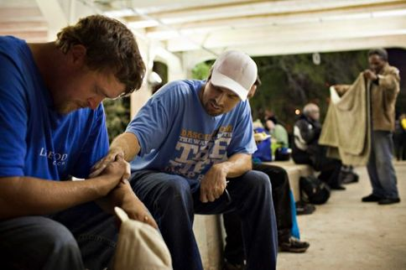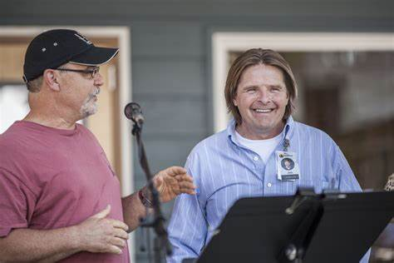

MENTORSHIP EXPECTATIONS
Timely reporting and consistent attention is essential to tracking the mentee's continued progress through his/her program. If accepted, you will:
Be assigned a mentee after signing a Mentoring Agreement Form. Meet with your mentee twice a month for at least 6 months. Submit a Progress Sheet each month to the Executive Director or Mentor Program Coordinator via email or in person.

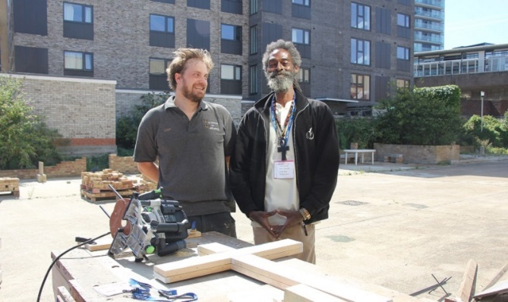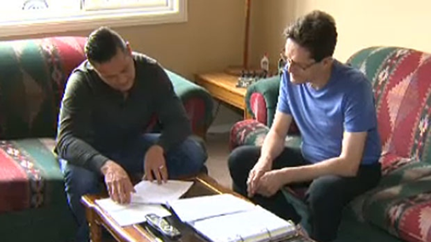
Thank you for your interest in being a positive influence in the life of those starting their journey to a new life. We look forward to meeting with you and want to encourage you in this growing relationship. Our prayer is that this is a blessing for you as you bless your mentee in this rewarding experience.

The completion of the Mentor Application does not guarantee admittance into the program. All approved applicants will be subject to a background check. If at any time a mentor is subject to elapse, their position as a mentor will be discontinued. We recommend you to seek counsel from appropriate sources.

We are pleased that you have decided to be involved in the life of a Pueblo Rescue Mission program resident. We believe that forming Godly and healthy relationships in the community will be immensely beneficial for our clients in their journey to stabilization and recovery.
Our goal is to help each resident experience Redemption, Recovery and Restoration through our Mission Recovery Program. Our Mentor program will be a crucial component of the Restoration piece.
The focus of the mentor/mentee relationship and conversations will be multifaceted:
- Accountability in working their program at The Mission.
- Supporting the resident as they walk through their journey of recovery and/or stabilization.
- Focusing on life after the Mission.
- Life Skills and Life Management.
- Helping them find a church home.
- Getting them plugged into a recovery community outside of the Mission.
- Developing a community of support outside of the Mission.
To get the process started, please do the following:
- Complete the Mentor Application and review the Statement of Faith.
- Read and keep the Mentoring Guidelines to give you an idea of the expectations of mentoring.
- All applications submitted will be reviewed by our Executive Director and Advisory Council members to determine the right fit.
- You will receive an email from the Executive Director to schedule an orientation if you are approved.
  - If you are not approved, you will receive an email and personal call from our Executive Director with further details.
Please note:
- All approved applicants will be subject to a background check.
- If a mentor is subject to relapse at any time, their position as a mentor will be discontinued.
- All mentors are expected to meet weekly online or in-person with their resident for a minimum of 6 months.
Thank you again for choosing to be a positive influence in the life of one of our clients. We look forward to meeting with you and want to encourage you in this growing relationship. Our prayer is that this is a blessing for you as you bless your mentee in this experience.
Sincerely,
Melanie Rapier & The Pueblo Rescue Mission Staff

Pueblo Rescue Mission
Mentor Application

First Name _____________________________ Last Name ___________________________________
Date ____________________________ Best Phone: _______________________________________
Alternate Phone: _______________________ Email:________________________________________
Your Church: ________________________________ Emergency Contact: _______________________
Emergency Contact Phone: __________________________ Relationship: _______________________
References and Ministry Experience:
Please list three references. If applicable, include a pastor or someone in your church leadership.
(1) First Name _________________________ Last Name _____________________________
Phone : ______________________________ Email__________________________________

(2) First Name _________________________ Last Name______________________________
Phone _______________________________ Email__________________________________

(3) First Name __________________________ Last Name______________________________
Phone ________________________________ Email __________________________________

Please list any ministry, leadership or community service roles:
_________________________________________________________________________________
_________________________________________________________________________________
_________________________________________________________________________________

Please answer the following questions:

1. What interests you in becoming a mentor for one of the members of this program?
_________________________________________________________________________________
_________________________________________________________________________________
_________________________________________________________________________________

2. Describe your perspective on how people become addicted to substances, and your perspective on how then people overcome addiction.
___________________________________________________________________________________
___________________________________________________________________________________
___________________________________________________________________________________

3. Realizing that this is a distinctly Christian organization, do you feel that you would have any conflict with the mission's goals and objectives? Why or why not?
___________________________________________________________________________________
___________________________________________________________________________________
___________________________________________________________________________________
4. List any goals you may have for this relationship and your plan of action to meet those goals.
___________________________________________________________________________________
___________________________________________________________________________________
___________________________________________________________________________________
___________________________________________________________________________________

5. Please list your hobbies and skills. We will use this information to match you with a mentee that shares your interests or that could benefit from your gifts.
___________________________________________________________________________________
___________________________________________________________________________________
___________________________________________________________________________________
___________________________________________________________________________________

6. How many mentees are you willing to mentor? __________________________________________

7. What is your availability to be a mentor? (Days/Times): ____________________________________
___________________________________________________________________________________

8. Please use this space to tell us anything else about yourself that you feel is important for us to know.
___________________________________________________________________________________
___________________________________________________________________________________
___________________________________________________________________________________

Substance Abuse/Addiction:
A. Do you currently have or ever had challenges related to substance abuse/addiction? ______________
_____________________________________________________________________________________
_____________________________________________________________________________________
_____________________________________________________________________________________
_____________________________________________________________________________________

B. If yes, how long have you been substance free? ____________________________________________

C. Briefly describe your addiction and the treatment program(s) that followed: _____________________
_____________________________________________________________________________________
_____________________________________________________________________________________
_____________________________________________________________________________________

I have answered all the above questions honestly and to the best of my ability. I understand that the submission of this application does not guarantee admittance into the mentoring program. I will not begin mentoring until I have spoken to and received instruction from the mentor program coordinator.
I acknowledge that all approved mentors will be subject to a background check and that results of that background check are not a sole determinant factor in program acceptance. I also understand that mentors who relapse will no longer be able to mentor clients.
I have read and understand the Statement of Faith that reflects the values of the Las Vegas Rescue Mission
I would like to receive email communications from the Mission with information about upcoming events and other ways I can help (circle one): YES NO

X ____________________________________ X_____________________________________
Mentee Signature Print Name

Mentor Guidelines

Time Commitment: Minimum of two meetings per month for six months online or in person. We encourage you to continue with your mentee after they have completed the program and moved off property.
Primary Goal: Focusing on life skills and management, getting connected in community outside. of the Mission, developing healthy relationships, learning to set healthy boundaries, healthy communication skills, personal and professional growth, good work ethic, and working their recovery.

Mentors will be provided with a curriculum/topic schedule for support for the first several weeks. This is designed for you to get to know your new mentee, set the tone for your weekly meetings, and start establishing a trusted professional relationship.

Always follow and keep safe and healthy boundaries (physical, emotional, financial, etc.).
Do not provide or share any personal information except for your phone number.
Say what you mean and mean what you say.
Please be on time. If you schedule a time to meet with your mentee, follow through and show up. •
Share your recovery story and what has helped you to be successful.
Encourage spiritual and personal growth.
Hold mentee accountable to working their program and the 12 steps.
Provide progress reports once a month to the Executive Director.
Report any concerns with the relationship or possible red flag issues to the Advisory Council staff and/or Executive Director immediately.
Ask for help and guidance when needed.
Please be creative and yet sincere. The mentee needs to see the message of your life more than the message of your lips. If, for any reason, you are concerned about something taking place within the mentee’s life that is inappropriate, or have a question about the mentoring program, please do not hesitate to contact Melanie Rapier or an Advisory Council member.

STATEMENT OF FAITH

The Pueblo Rescue Mission is committed to the foundational doctrines of the Christian faith. We consider the following doctrines to be essential:
ABOUT GOD: The existence of one God, who eternally exists in three persons: Father, Son and Holy Spirit.
ABOUT THE BIBLE: The Bible is God’s Word to all men. It was written by human authors, under inspiration of the Holy Spirit. It is our sole authority for faith and practice.
ABOUT JESUS CHRIST: Jesus Christ is God’s only son, born of the virgin Mary by the Holy Spirit. We affirm His Miracles, His Message, and His death on Calvary’s cross. He bodily arose from the grave, sits at the right hand of God, intercedes for the Church, and prepares all things for His imminent return.
ABOUT MAN: Man is made in the spiritual image of God and yet, through Adam, has become captive to sin and death. This sin separates man from God.
ABOUT SALVATION: Salvation is a gift from God to man. Salvation is by grace, through faith in the Lord Jesus Christ, apart from all works of righteousness.
ABOUT THE CHURCH: The church is the visible Body of Christ, of which Jesus is the head. The Church is commissioned to make disciples of all peoples and nations.
ABOUT THE HOLY SPIRIT: The Holy Spirit is equal with the Father and Son as God. He is present in the world to make men aware of their need for Jesus Christ. The Spirit lives in every Christian from the moment of salvation. He provides the Christian with power for living, understanding of spiritual truth, and guidance in doing what is right.
ABOUT ETERNITY: Man was created to exist forever. He will either exist eternally separated from God by sin, or in union with God through forgiveness and salvation. To be eternally separated from God is Hell. To be eternally in union with Him is eternal life.
CHRIST’S RETURN: Jesus ascended to Heaven’s glory and will return again to earth to reign as King of kings, and Lord of lords.

X _______________________________________ X____________________________________
Mentee Signature Mentee Printed Name

